Theory Assignment 1 Rihan TIB71
Q1.E-learning Course Page
index.html
<!DOCTYPE html>
<html lang="en">
<head>
<meta charset="UTF-8">
<meta name="viewport" content="width=device-width, initial-scale=1.0">
<title>E-Learning Course Page</title>
<link rel="stylesheet" href="style.css">
</head>
<body>
<!-- Header section containing the course title and navigation -->
<header>
<h1>Web Basics Bootcamp</h1>
<p>Learn HTML, CSS, and JavaScript step by step.</p>

<!-- Semantic navigation bar with module links -->
<nav aria-label="Main navigation">
<ul class="nav-list">
<li><a href="#home">Home</a></li>
<li><a href="#modules">Modules</a></li>
<li><a href="#videos">Videos</a></li>
<li><a href="#resources">Resources</a></li>
<li><a href="#feedback">Feedback</a></li>
</ul>
</nav>
</header>

<!-- Main page content -->
<main>
<!-- Section 1: Course overview and module list -->
<section id="home" class="card">
<h2>Course Overview</h2>
<article>
<h3>What You Will Learn</h3>
<p>
This beginner course helps you build strong web development fundamentals.
You will practice structure, styling, and basic interactivity.
</p>
<ul>
<li>Write semantic HTML pages</li>
<li>Style pages with CSS and Flexbox</li>
<li>Create simple dynamic behavior using JavaScript</li>
</ul>
</article>
</section>

<!-- Section 2: Modules in ordered list format -->
<section id="modules" class="card">
<h2>Course Modules</h2>
<article>
<h3>Learning Path</h3>
<ol>
<li>Introduction to HTML</li>
<li>CSS Layout and Styling</li>
<li>Responsive Web Design Basics</li>
<li>JavaScript Fundamentals</li>
</ol>
</article>
</section>

<!-- Section 3: Embedded video lesson -->
<section id="videos" class="card">
<h2>Featured Video Lesson</h2>
<article>
<h3>HTML Crash Course</h3>
<div class="video-wrapper">
<iframe
src="https://www.youtube.com/embed/qz0aGYrrlhU"
title="YouTube video player"
allow="accelerometer; autoplay; clipboard-write; encrypted-media; gyroscope; picture-in-picture"
allowfullscreen>
</iframe>
</div>
</article>
</section>

<!-- Section 4: Downloadable resource links -->
<section id="resources" class="card">
<h2>Downloadable Resources</h2>
<article>
<h3>Study Material</h3>
<ul>
<li><a href="#">HTML Quick Guide (PDF)</a></li>
<li><a href="#">CSS Practice Notes</a></li>
<li><a href="#">JavaScript Basics Worksheet</a></li>
</ul>
</article>
</section>

<!-- Section 5: Basic feedback form (no JavaScript) -->
<section id="feedback" class="card">
<h2>Course Feedback</h2>
<form action="#" method="post">
<label for="name">Name</label>
<input type="text" id="name" name="name" placeholder="Enter your name" required>

<label for="email">Email</label>
<input type="email" id="email" name="email" placeholder="Enter your email" required>

<label for="message">Message</label>
<textarea id="message" name="message" rows="5" placeholder="Share your feedback..." required></textarea>

<button type="submit">Submit Feedback</button>
</form>
</section>
</main>

<!-- Footer information -->
<footer>
<p>&copy; 2026 Web Basics Bootcamp. All rights reserved.</p>
</footer>
</body>
</html>

style.css
/* Basic reset for consistent spacing across browsers */
* {
margin: 0;
padding: 0;
box-sizing: border-box;
}

/* Page-level styling for readable typography and soft background */
body {
font-family: Arial, sans-serif;
line-height: 1.6;
background-color: #f4f7fb;
color: #1f2937;
}

/* Header styling to create clear visual separation */
header {
background-color: #1d4ed8;
color: #ffffff;
padding: 1.5rem 1rem;
text-align: center;
}

header p {
margin-top: 0.4rem;
}

/* Flexbox navbar for horizontal links on wider screens */
nav {
margin-top: 1rem;
}

.nav-list {
list-style: none;
display: flex;
justify-content: center;
gap: 1rem;
flex-wrap: wrap;
}

.nav-list a {
color: #ffffff;
text-decoration: none;
padding: 0.5rem 0.8rem;
border-radius: 6px;
transition: background-color 0.2s ease;
}

.nav-list a:hover {
background-color: rgba(255, 255, 255, 0.2);
}

/* Main content container */
main {
max-width: 900px;
margin: 1.5rem auto;
padding: 0 1rem;
}

/* Card style used by each section to keep layout clean */
.card {
background-color: #ffffff;
padding: 1.2rem;
border-radius: 10px;
box-shadow: 0 4px 12px rgba(0, 0, 0, 0.08);
margin-bottom: 1.2rem;
}

h2 {
margin-bottom: 0.8rem;
color: #1e3a8a;
}

h3 {
margin-bottom: 0.6rem;
}

ul,
ol {
margin-left: 1.2rem;
margin-top: 0.5rem;
}

/* Responsive YouTube embed container */
.video-wrapper {
position: relative;
width: 100%;
padding-top: 56.25%;
border-radius: 8px;
overflow: hidden;
margin-top: 0.8rem;
}

.video-wrapper iframe {
position: absolute;
top: 0;
left: 0;
width: 100%;
height: 100%;
border: 0;
}

/* Basic form styling */
form {
display: flex;
flex-direction: column;
gap: 0.6rem;
}

input,
textarea {
padding: 0.6rem;
border: 1px solid #cbd5e1;
border-radius: 6px;
font-size: 1rem;
}

button {
width: fit-content;
padding: 0.7rem 1rem;
border: none;
border-radius: 6px;
background-color: #2563eb;
color: #ffffff;
cursor: pointer;
}

button:hover {
background-color: #1e40af;
}

footer {
text-align: center;
padding: 1rem;
background-color: #111827;
color: #ffffff;
margin-top: 1rem;
}

/* On small screens, stack nav links vertically for readability */
@media (max-width: 600px) {
.nav-list {
flex-direction: column;
align-items: center;
}

.card {
padding: 1rem;
}
}

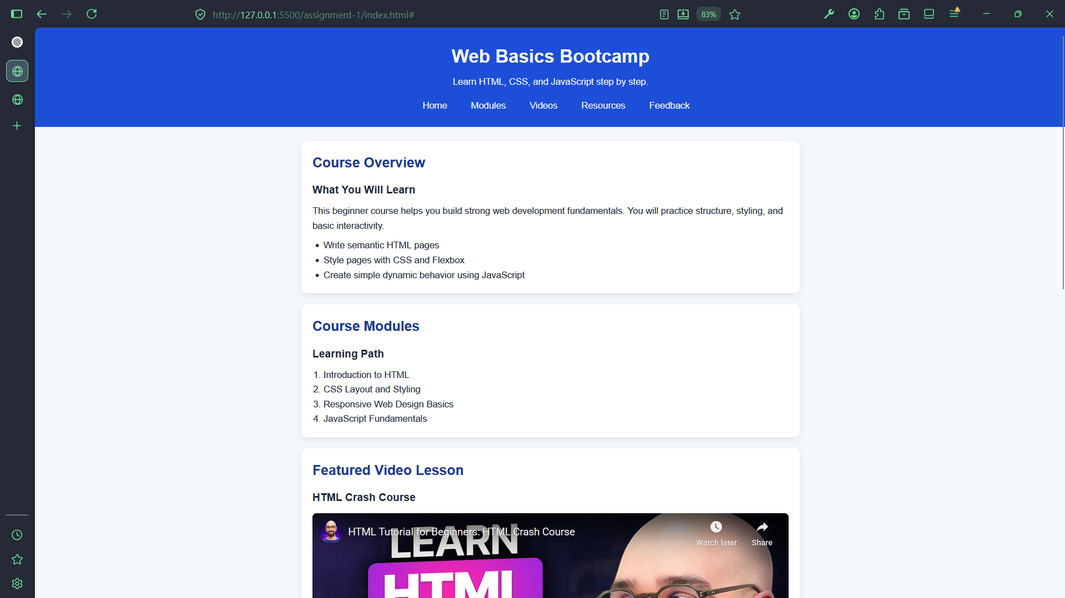

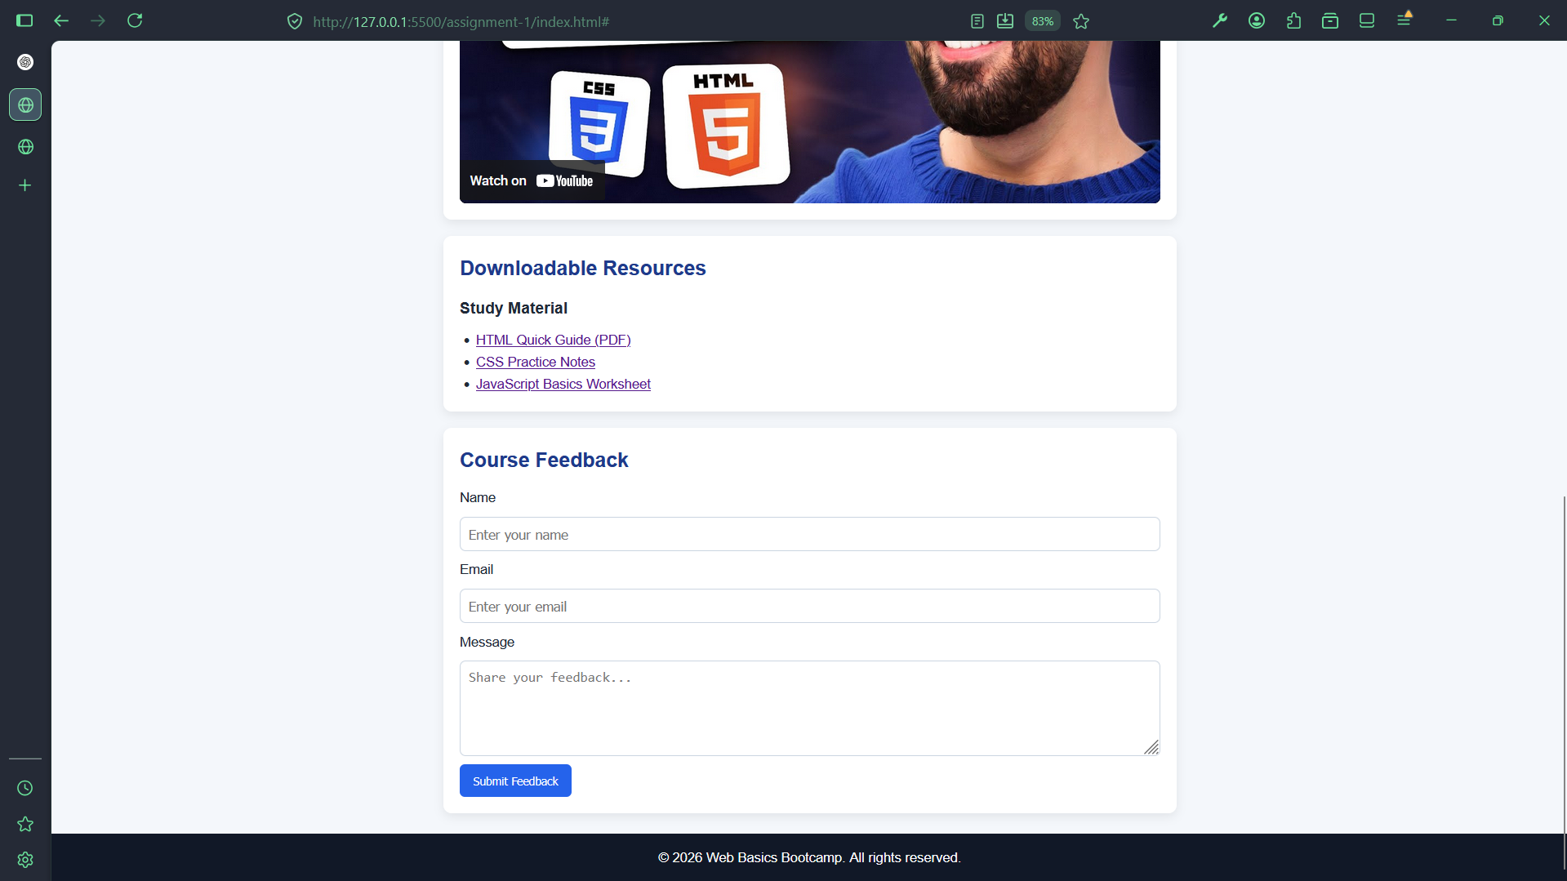
Q2. Dynamic Feedback Form
index.html
<!DOCTYPE html>
<html lang="en">
<head>
<meta charset="UTF-8">
<meta name="viewport" content="width=device-width, initial-scale=1.0">
<title>Dynamic Feedback Form</title>
<link rel="stylesheet" href="style.css">
</head>
<body>
<main class="form-page">
<section class="form-card">
<h1>Course Feedback Form</h1>
<p>Please fill out all fields before submitting your feedback.</p>

<!-- Form uses novalidate so custom JavaScript validation can handle messages -->
<form id="feedbackForm" novalidate>
<div class="field-group">
<label for="name">Name</label>
<input type="text" id="name" name="name" placeholder="Enter your name">
<small class="error" id="nameError"></small>
</div>

<div class="field-group">
<label for="email">Email</label>
<input type="email" id="email" name="email" placeholder="Enter your email">
<small class="error" id="emailError"></small>
</div>

<div class="field-group">
<label for="rating">Rating (1 to 5)</label>
<select id="rating" name="rating">
<option value="">Select rating</option>
<option value="1">1</option>
<option value="2">2</option>
<option value="3">3</option>
<option value="4">4</option>
<option value="5">5</option>
</select>
<small class="error" id="ratingError"></small>
</div>

<div class="field-group">
<label for="comments">Comments</label>
<textarea id="comments" name="comments" rows="4" placeholder="Write your comments..."></textarea>
<small class="error" id="commentsError"></small>
</div>

<button type="submit">Submit Feedback</button>
<p id="successMessage" class="success"></p>
</form>
</section>
</main>

<script src="script.js"></script>
</body>
</html>

style.css
/* Center the form card on the page */
body {
margin: 0;
font-family: Arial, sans-serif;
background-color: #f0f4f8;
color: #1f2937;
}

.form-page {
min-height: 100vh;
display: flex;
align-items: center;
justify-content: center;
padding: 1rem;
}

/* Simple card layout for beginner-friendly styling */
.form-card {
width: 100%;
max-width: 450px;
background-color: #ffffff;
padding: 1.5rem;
border-radius: 10px;
box-shadow: 0 4px 14px rgba(0, 0, 0, 0.1);
}

h1 {
margin-top: 0;
margin-bottom: 0.5rem;
color: #1e3a8a;
}

p {
margin-top: 0;
margin-bottom: 1rem;
}

.field-group {
margin-bottom: 1rem;
}

label {
display: block;
margin-bottom: 0.4rem;
font-weight: bold;
}

input,
select,
textarea {
width: 100%;
padding: 0.6rem;
border: 1px solid #cbd5e1;
border-radius: 6px;
font-size: 1rem;
}

button {
width: 100%;
padding: 0.7rem;
border: none;
border-radius: 6px;
background-color: #2563eb;
color: #ffffff;
font-size: 1rem;
cursor: pointer;
}

button:hover {
background-color: #1e40af;
}

/* Error text shown under each input field */
.error {
display: block;
margin-top: 0.3rem;
color: #dc2626;
min-height: 1rem;
}

/* Success message shown after valid submission */
.success {
margin-top: 1rem;
color: #15803d;
font-weight: bold;
min-height: 1.2rem;
}

script.js
// Get form and field references once so we can reuse them in functions.
const form = document.getElementById("feedbackForm");
const nameInput = document.getElementById("name");
const emailInput = document.getElementById("email");
const ratingInput = document.getElementById("rating");
const commentsInput = document.getElementById("comments");

const nameError = document.getElementById("nameError");
const emailError = document.getElementById("emailError");
const ratingError = document.getElementById("ratingError");
const commentsError = document.getElementById("commentsError");
const successMessage = document.getElementById("successMessage");

// Validation function for name: must not be empty.
function validateName() {
const nameValue = nameInput.value.trim();

if (nameValue === "") {
nameError.textContent = "Name is required.";
return false;
}

nameError.textContent = "";
return true;
}

// Validation function for email using a simple regex format check.
function validateEmail() {
const emailValue = emailInput.value.trim();
const emailPattern = /^[^\s@]+@[^\s@]+\.[^\s@]+$/;

if (emailValue === "") {
emailError.textContent = "Email is required.";
return false;
}

if (!emailPattern.test(emailValue)) {
emailError.textContent = "Please enter a valid email address.";
return false;
}

emailError.textContent = "";
return true;
}

// Validation function for rating: must be selected and between 1 and 5.
function validateRating() {
const ratingValue = Number(ratingInput.value);

if (ratingInput.value === "") {
ratingError.textContent = "Rating is required.";
return false;
}

if (ratingValue < 1 || ratingValue > 5) {
ratingError.textContent = "Rating must be between 1 and 5.";
return false;
}

ratingError.textContent = "";
return true;
}

// Validation function for comments: must not be empty.
function validateComments() {
const commentsValue = commentsInput.value.trim();

if (commentsValue === "") {
commentsError.textContent = "Comments are required.";
return false;
}

commentsError.textContent = "";
return true;
}

// Run all validation functions and return true only when all are valid.
function validateForm() {
const isNameValid = validateName();
const isEmailValid = validateEmail();
const isRatingValid = validateRating();
const isCommentsValid = validateComments();

return isNameValid && isEmailValid && isRatingValid && isCommentsValid;
}

// Handle submit event: prevent default submit, show errors or success message.
form.addEventListener("submit", function (event) {
event.preventDefault();
successMessage.textContent = "";

if (validateForm()) {
successMessage.textContent = "Feedback submitted successfully!";
form.reset();
}
});

// Optional live validation: checks each field after the user leaves the input.
nameInput.addEventListener("blur", validateName);
emailInput.addEventListener("blur", validateEmail);
ratingInput.addEventListener("blur", validateRating);
commentsInput.addEventListener("blur", validateComments);

